**High Performance Sport New Zealand**

**Weather App for Training Venues**

Preparing our athletes to perform in all conditions abroad

Original authors: Ben Day

Editors:

Date created: March 2020

Last updated: 17/03/2020

# **Purpose and motivating question**

An enduring question for HPSNZ providers is “*what is the weather going to be like at venue X in month Y*”. Environmental conditions can vary significantly across international venues and this places different demands on physical performance.

For the upcoming Olympic and Paralympic Venue, significant resource has enabled a growing understanding of the heat demands of the Tokyo environment – hence prompting pragmatic heat strategies in training and habits – but what about other competition venues?

|  |  |
| --- | --- |
| **Why** | Athletes and coaches can be better prepared for environments in which they compete by being equipped with facts about the weather. |
|  |  |
| **How** | HPSNZ providers can provide accurate information and relevant recommendations to assist training and operational preparation for upcoming competitions. By leveraging global weather data sources, answers to the above question can be found quickly, repeatably, consistently, and for any venue and time period. |
|  |  |
| **What** | Intelligence can create a self-service tool to allow a user to select an international city and time period, for which relevant weather data can be presented. These data will be historical records from weather stations and global weather models. Output data is summarised into digestible and meaningful metrics that a provider can communicate to sports. |

**Initial engagement**

Data Analyst Ben Day had been providing specific insights regarding Tokyo 2020 Olympic training camp venues for a variety of sport physiologists in 2017-2020. As these requests grew in scope and frequency it became clear that there could be an improved method of answering the enduring question, and thereby prime the athletes and coaches with this information more seamlessly.

To progress from the resource-heavy manual data gathering that was in place, it was believed a self-service analytics tool could be used as a solution. Ideally a physiology (or others) could use an app to find answers about the weather conditions of any prospective training or competition venue.

## Data Sources

Head of Intelligence Chris Rawlings discovered New Zealand Cricket utilise the [**Dark Sky API**](https://darksky.net/dev) for ball-by-ball data on weather conditions during competition. After some research into the underlying data sources that the API uses it was decided to trial this for our purpose. As explained in detail [here](https://darksky.net/dev/docs/sources), the Dark Sky API aggregates weather station data and global weather model outputs to provide both historical and “hyperlocal” forecasts for a given location.

A trial period revealed the applicability of this API for the original purpose. Other important factors for its use include:

* API accessibility via URL
* Ability to output data sources used for each API call
* Ability to specify any time and any location (longitude and latitude) for each API call
* Ability to output “distance to nearest weather station” for each API call

## User Interface

To effectively benefit a sport provider the weather tool must be easy to use. Dashboards in Tableau and PowerBI were considered for this, but the flexibility of RStudio and Shiny apps was decided to be the most appropriate option. This is because the R Shiny app could facilitate the manipulation, analysis, and presentation of data while also bridging skills between programming and web application design to enable simple app development. Secondly, using RStudio with Github allows version control in a way that we can easily track changes and store all project resources (data, docs, scripts) in a repository.

**Inputs**

* Dates of period
* Venue (city – country)
* Number of years historical data (1 – 10 years)

**Outputs**

* Range (min and max) of the following metrics
  + Apparent temperature (°C)
  + Temperature (°C)
  + Relative humidity (%)
* Percentage of days in period where apparent temperature above thresholds
  + 30°C
  + 35°C
  + 40°C

**Web application**

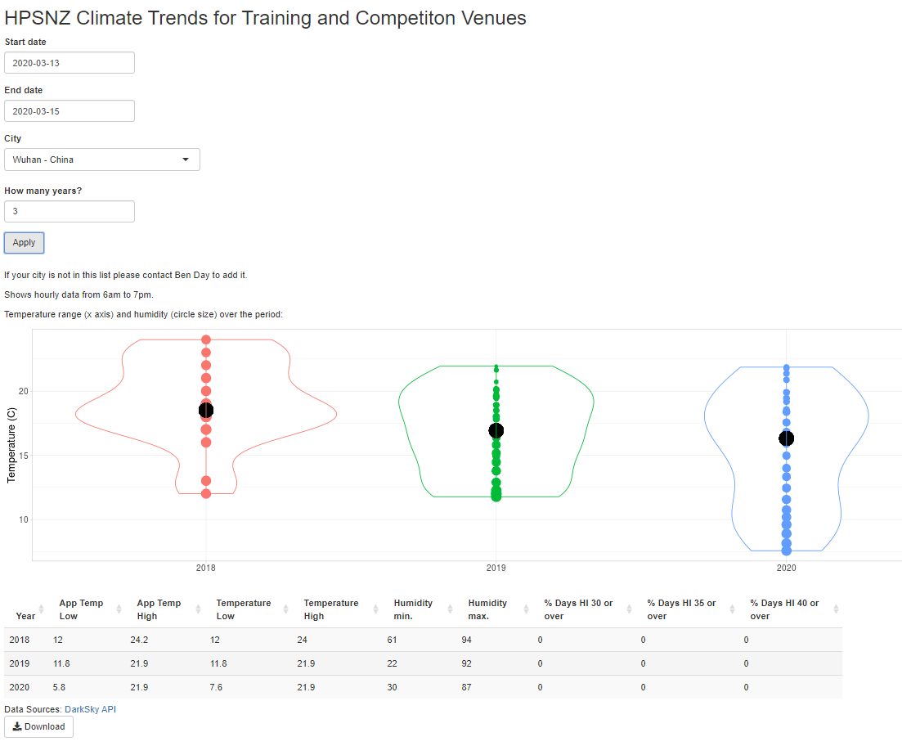

# **Implementation**

A key driver for this project is the aspect of continuous improvement in our methods. By building a web application the solution can be iterative and can be gradually enhanced to better suit our end users (providers, athletes, and coaches). Feedback is crucial in this process.

**Version 1**

The initial version of the app was shared with a collaboration group between HPSNZ teams. Innovation and Performance Technique Analysis teams provided feedback on the interface, underlying data and usability. This prompted the following adjustments:

* Change view from “by day” to “by year”
* Addition of a “progress bar” that would display progress in loading API data
* Clearer labelling of metrics in data table
* Easier searching/selecting venue from list

**Version 2**

Cycling New Zealand staff were shown version 2 of the app to prompt some thinking in an Intelligence introduction meeting in early 2020. This live demonstration exposed some “missing” cities from the list of 12,000+ venues. It was clear that there needed to be a fast way for the data analyst to add cities to the list in order that we remain responsive to sport needs. Hence, version 2 was improved by:

* Writing a function to quickly add city (from latitude, longitude) to the city list dataset

**Version 3**

The app was made available to wider physiology team, specifically to assist in upcoming planning of “heat camps” (where sports travel to venues for exposure to certain environmental conditions that replicate upcoming competition). As usage increased, the trial subscription became limiting in number of API calls per day. At this point it was arranged that the HPSNZ Dark Sky API subscription could be upgraded to allow a higher limit of daily calls. Hence, the tool has been enhanced as below, with the ability to monitor ongoing usage.

* High nominal limit of daily API calls (10,000 calls per USD and easily scalable as required)

# **Next steps**

The nature of this solution as a web application allows for continual improvements in software development style. New versions of the tool can be implemented as user demands change, and minor changes can be quickly made (for example, adding new cities to the venue list can be done very quickly).

## Ongoing responsiveness

To value responsiveness and a focus on empowering the end user, Intelligence must have an ongoing commitment to responding to received feedback. Source code has been written in a shareable and readable way and stored in a Github repository for transparency and future access.

## NIWA review

Intelligence engaged with NIWA (National Institute of Water and Atmospheric Research) to assess the underlying quality of methods the weather primer tool uses. HPSNZ can leverage NIWA’s undeniable scientific and meteorological expertise to ensure the quality of data analysis and messaging for our original purpose.

Head of Intelligence Chris Rawlings met Kameron Christopher from NIWA (Head of High Performance Computing) at the NZ Data Governance Summit in February and arranged an initial meeting to discuss this potential collaboration opportunity. Chris and Ben conveyed the areas of opportunity we see in working with NIWA, and a review of this existing tool ensued.

Specific areas that could benefit from expert oversight include:

1. Data source – limitations and benefits of using Dark Sky API
2. Methodology – appropriateness of observation frequency and measures
3. Outputs – assess chosen way of summarising data

Initially this document will be shared with NIWA for familiarisation. A follow-up meeting can then occur to agree terms of the intended review.